Packetizer Functional Design Specifications
  - Design and Implementation of CSI Controller IP
  - Version 4.0.1

  - Block Owner
Hana Samy Ahmed
  - Authors
Hana Samy Ahmed

This Page is left Blank Intentionally

Table of Contents
1 Table of Contents 1
2 Revision History 2
3 Overview 3
4 Operation and Description 3
4.1 Digital Interface 3
4.1.1 Parameters Names 3
4.1.2 Ports Names 3
4.2 Functional Description 3
4.3 Block Diagram 3
4.4 Timing Diagram 3
4.5 Verification Requirements 3

Revision History
Version | Date | Author(s) | Revision Notes | Owner Approval
1 | 21-1-2026 | Hana Samy

Overview
The CSI-2 Packetizer is responsible for encapsulating the raw sequential byte stream received from the Pixel-to-Byte Converter into valid MIPI CSI-2 Low Level Protocol (LLP) packets.
Its primary function is to generate and insert the Packet Header (PH) at the start of a line and append the Packet Footer (PF/CRC) at the end of a line. It also handles Frame Start (FS) and Frame End (FE) Short Packets.
Crucially, this block resolves the timing alignment challenge where the upstream module asserts control flags coincident with data. It utilizes a 5-Stage Pipeline Delay in the data path to allow sufficient time for the Packet Header to be inserted before the payload data flows through, ensuring protocol compliance without stalling the pipeline.

Operation and Description

Digital Interface

Ports Names
Port Name | Port Width | Port Type | Description
Clocks & Resets
i_byte_clk | 1 | Input | High-speed Byte Clock.
i_rst_n | 1 | Input | Active-low Asynchronous Reset.
Upstream Interface
i_p2b_data | 8 | Input | Serialized byte data payload.
i_p2b_valid | 1 | Input | Valid flag for input data.
o_p2b_ready | 1 | Output | Backpressure signal.
i_p2b_line_start | 1 | Input | PH Trigger: Asserts coincident with Byte 0.
i_p2b_packet_done | 1 | Input | PF Trigger: Asserts coincident with Last Byte.
i_p2b_frame_start | 1 | Input | FS Trigger.
i_p2b_frame_end | 1 | Input | FE Trigger.
Configuration (From Register File)
i_cfg_wc | 16 | Input | Word Count for the Header.
i_cfg_dt | 6 | Input | Data Type code for the Header.
i_cfg_vc_id | 2 | Input | Virtual Channel ID (0-3) for the Packet Header.
i_cfg_crc_en | 1 | Input | CRC Enable. (Passed to FSM and CRC Block).
Downstream Interface (To D-PHY)
o_tx_data | 8 | Output | Final Packet Stream.
o_tx_valid | 1 | Output | Valid flag.
i_tx_ready | 1 | Input | Backpressure from D-PHY.

Functional Description
The architecture is defined by three distinct functional units interacting together:
1. The 5-Stage Pipeline Delay (Data Path)
- Role: Buffers the payload data (i_p2b_data) to introduce a deterministic latency (5 cycles).
- Alignment: This allows the "Header Generator" enough time to transmit the Packet Header on the output bus before the first byte of the payload appears at the MUX input.
2. Dedicated CRC Engine (Separate Block)
- Role: A standalone submodule dedicated solely to checksum calculation.
- Input: It snoops the non-delayed input stream (i_p2b_data and i_p2b_valid).
- Operation: Resets on line_start, accumulates checksum on valid bytes, and outputs crc_out.
- Enable: If i_cfg_crc_en is LOW, this block is disabled to save power.
3. FSM Controller (Control Path)
- Role: Orchestrates the timing and MUX selection.
- Header Generation: On line_start, it takes control of the MUX to send the 4-byte Header.
  - Data ID Construction: The FSM concatenates the new input i_cfg_vc_id [1:0] with i_cfg_dt [5:0] to form the first byte of the header (DI).
  - ECC Calculation: It calculates ECC based on this dynamic Data ID and the Word Count.
- Payload Transmission: After the header, it switches the MUX to the Pipeline output.
- Footer Insertion:
  - When packet_done (delayed) is received, if i_cfg_crc_en is Enabled, the FSM selects crc_out from the CRC Engine.
  - If Disabled, the packet ends immediately.

Block Diagram
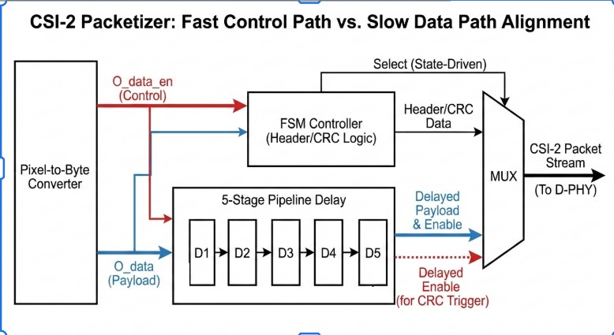

Timing Diagram
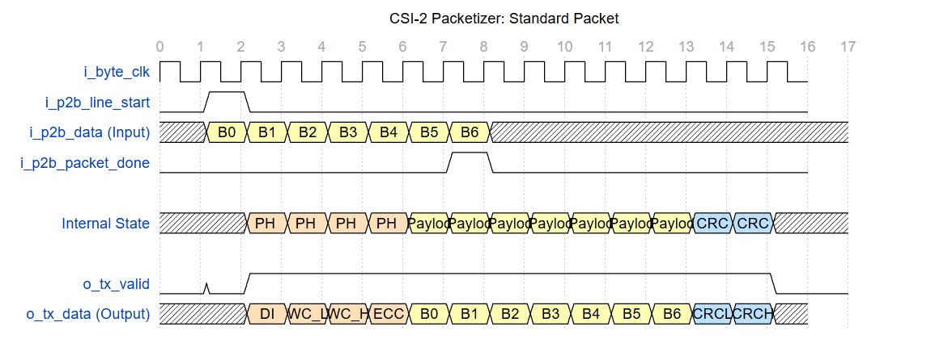
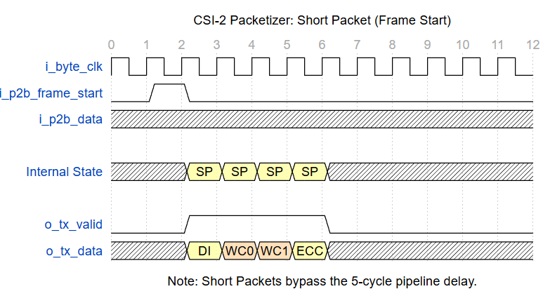

Verification Requirements
- Header Integrity: Verify that the ECC generated matches the Data ID and Word Count.
- Pipeline Latency: Ensure exactly 5 cycles of latency are observed between input Byte 0 and output Byte 0.
- CRC Disable Feature:
- Set i_cfg_crc_en to 0.
- Verify that the packet ends immediately after the last byte of payload.
- Confirm no extra bytes (Footer) are appended to the output stream.
- Backpressure Handling: Assert i_tx_ready low during Header, Payload, and Footer phases to ensure no data loss.

